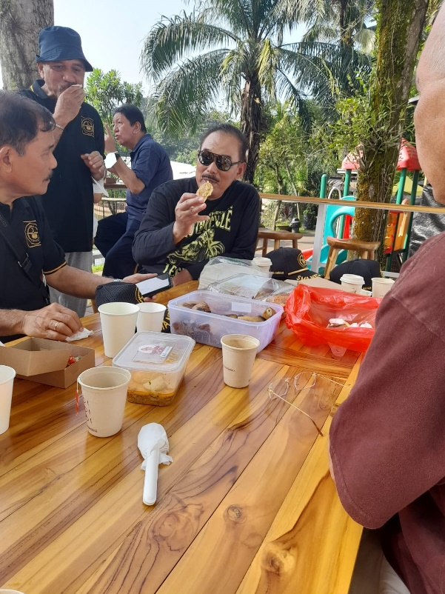 | 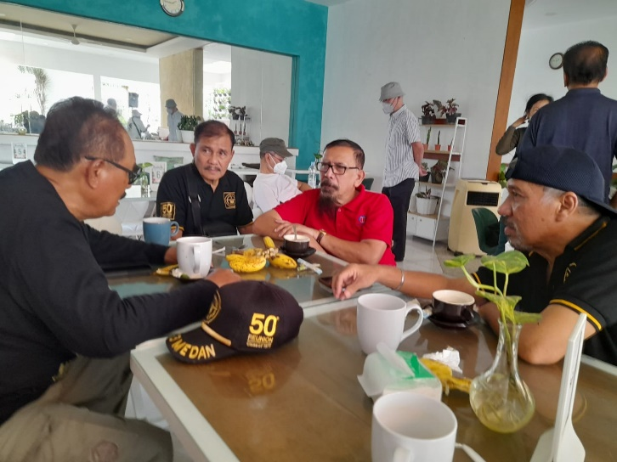

SISNO ADIWINOTO: A MAN TO BE!!!
https://getfit.my.id/renungan/2022/09/01/sisno-adiwinoto-a-man-to-be-3/

https://getfit.my.id/renungan/2022/09/01/sisno-adiwinoto-a-man-to-be-4/
https://www.antaranews.com/berita/3092649/alasan-pembahasan-perpres-dewan-keamanan-nasional-perlu-dihentikan

